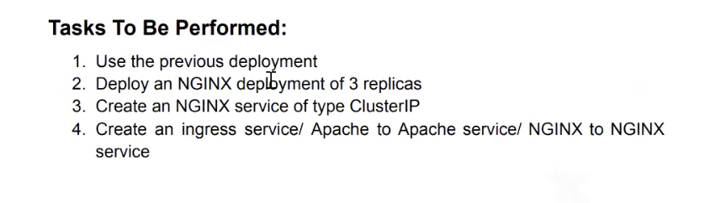

Type the command sudo nano ingress.yaml

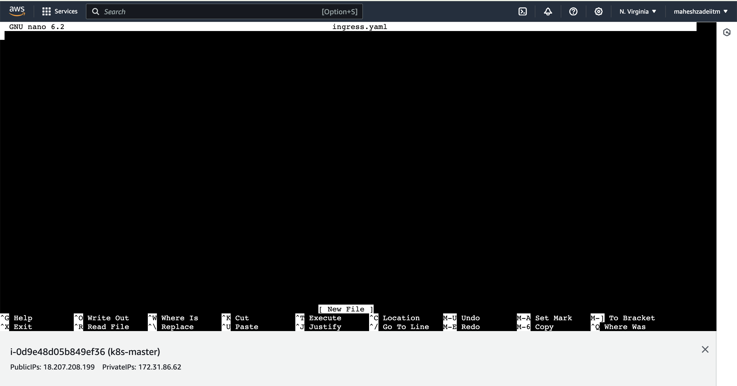

Copy the code from the Kubernetes website

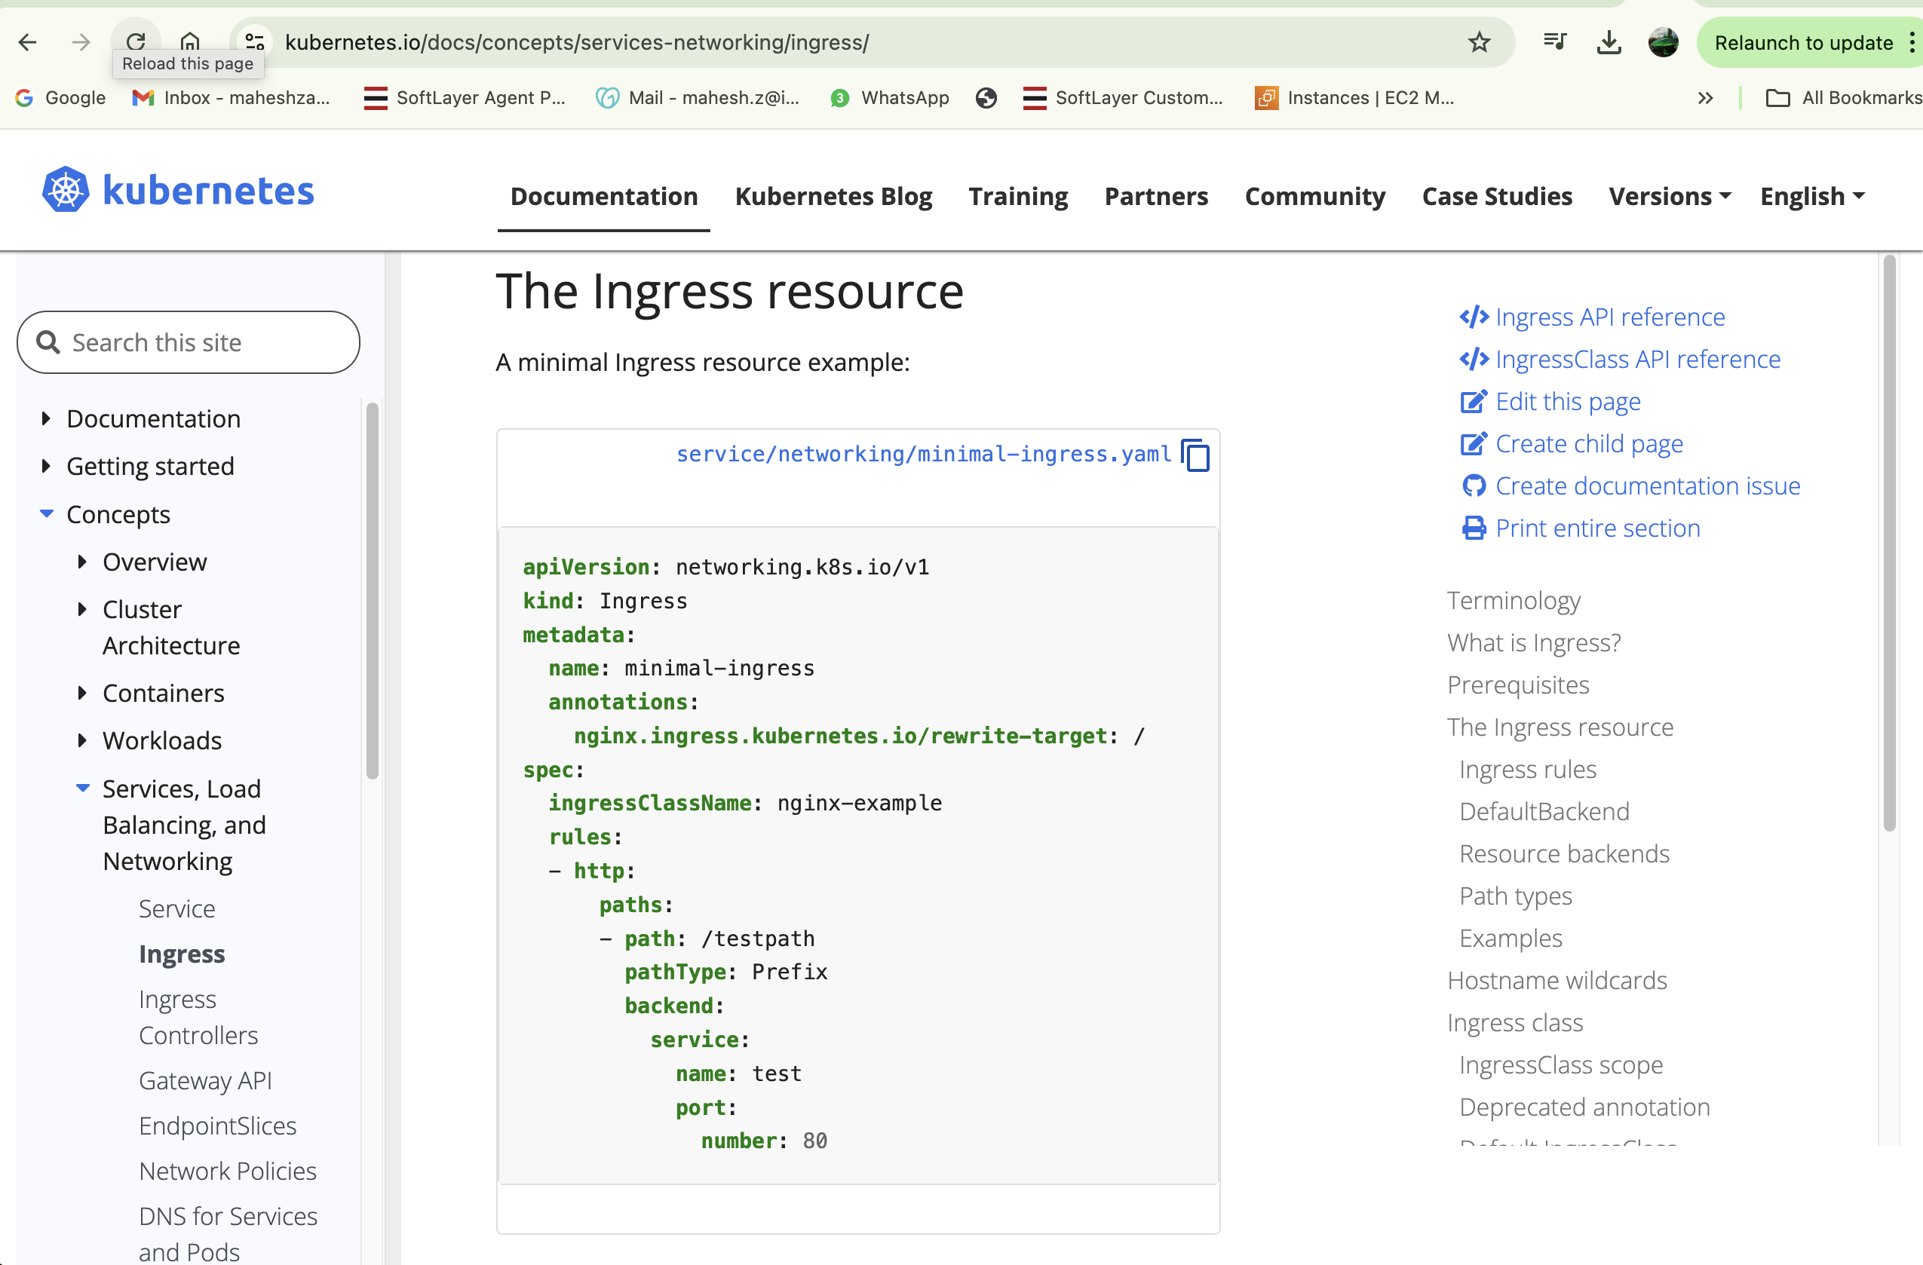

apiVersion: networking.k8s.io/v1

kind: Ingress

metadata:

name: minimal-ingress

annotations:

nginx.ingress.kubernetes.io/rewrite-target: /

spec:

ingressClassName: nginx-example

rules:

- http:

paths:

- path: /nginx

pathType: Prefix

backend:

service:

name: my-service

port:

number: 80

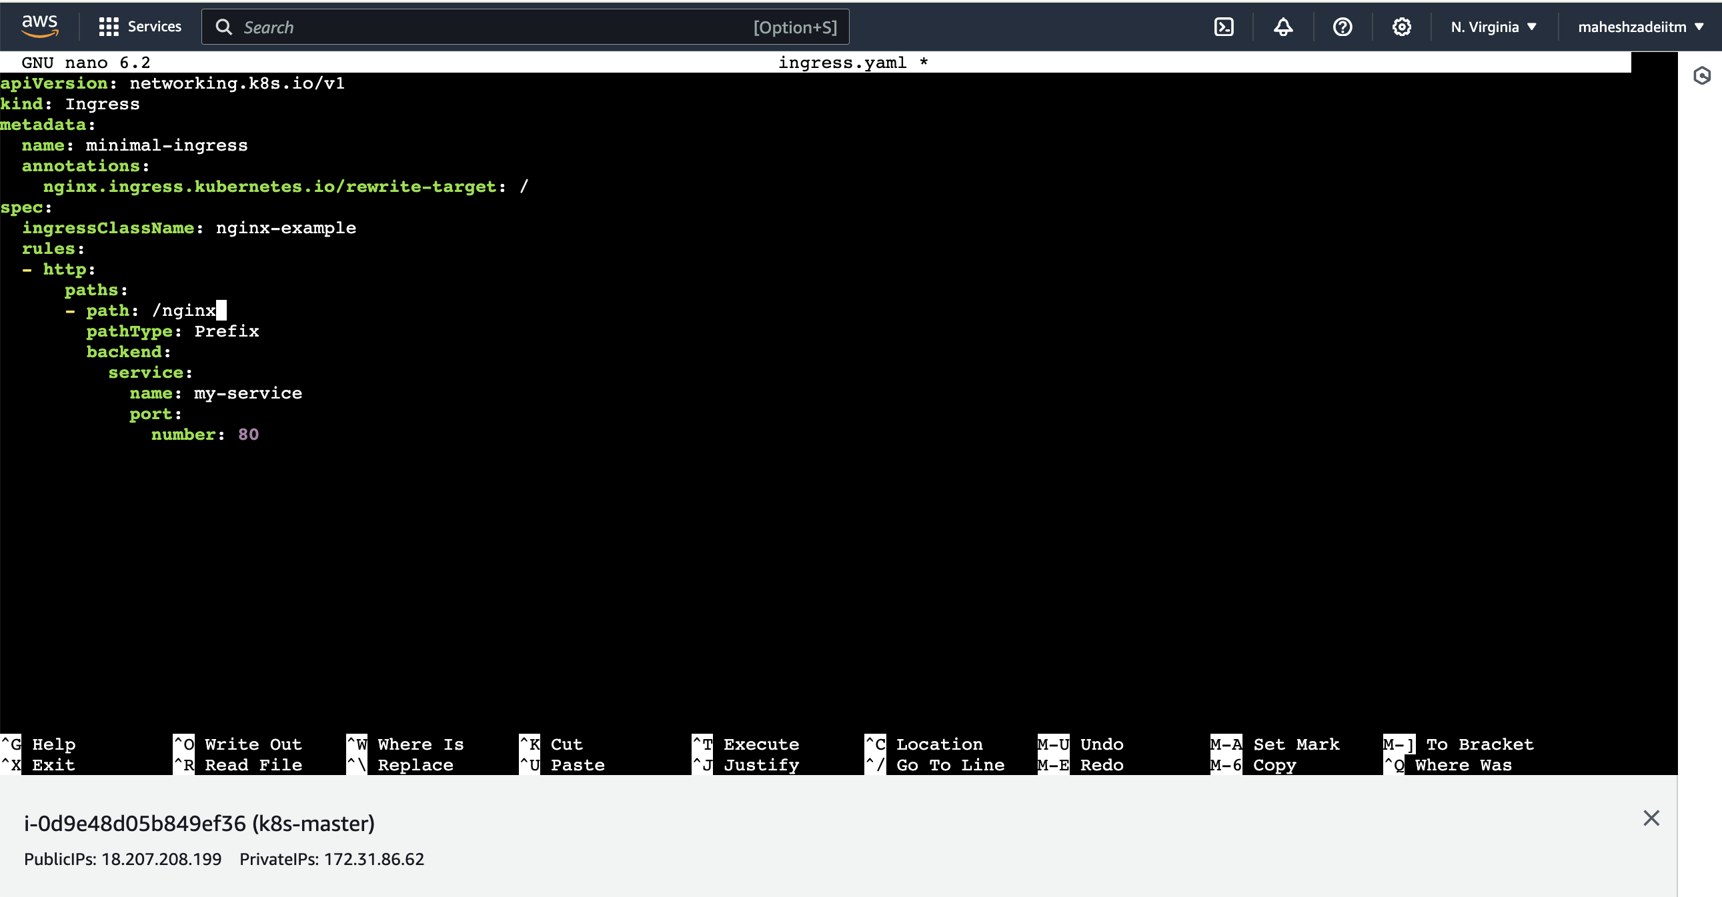

Save the file

ubuntu@ip-172-31-86-62:~$ sudo su

root@ip-172-31-86-62:/home/ubuntu# sudo nano ingress.yaml

root@ip-172-31-86-62:/home/ubuntu# kubectl apply -f ingress.yaml

ingress.networking.k8s.io/minimal-ingress created

root@ip-172-31-86-62:/home/ubuntu# kubectl get ing

NAME CLASS HOSTS ADDRESS PORTS AGE

minimal-ingress nginx-example \* 80 67s

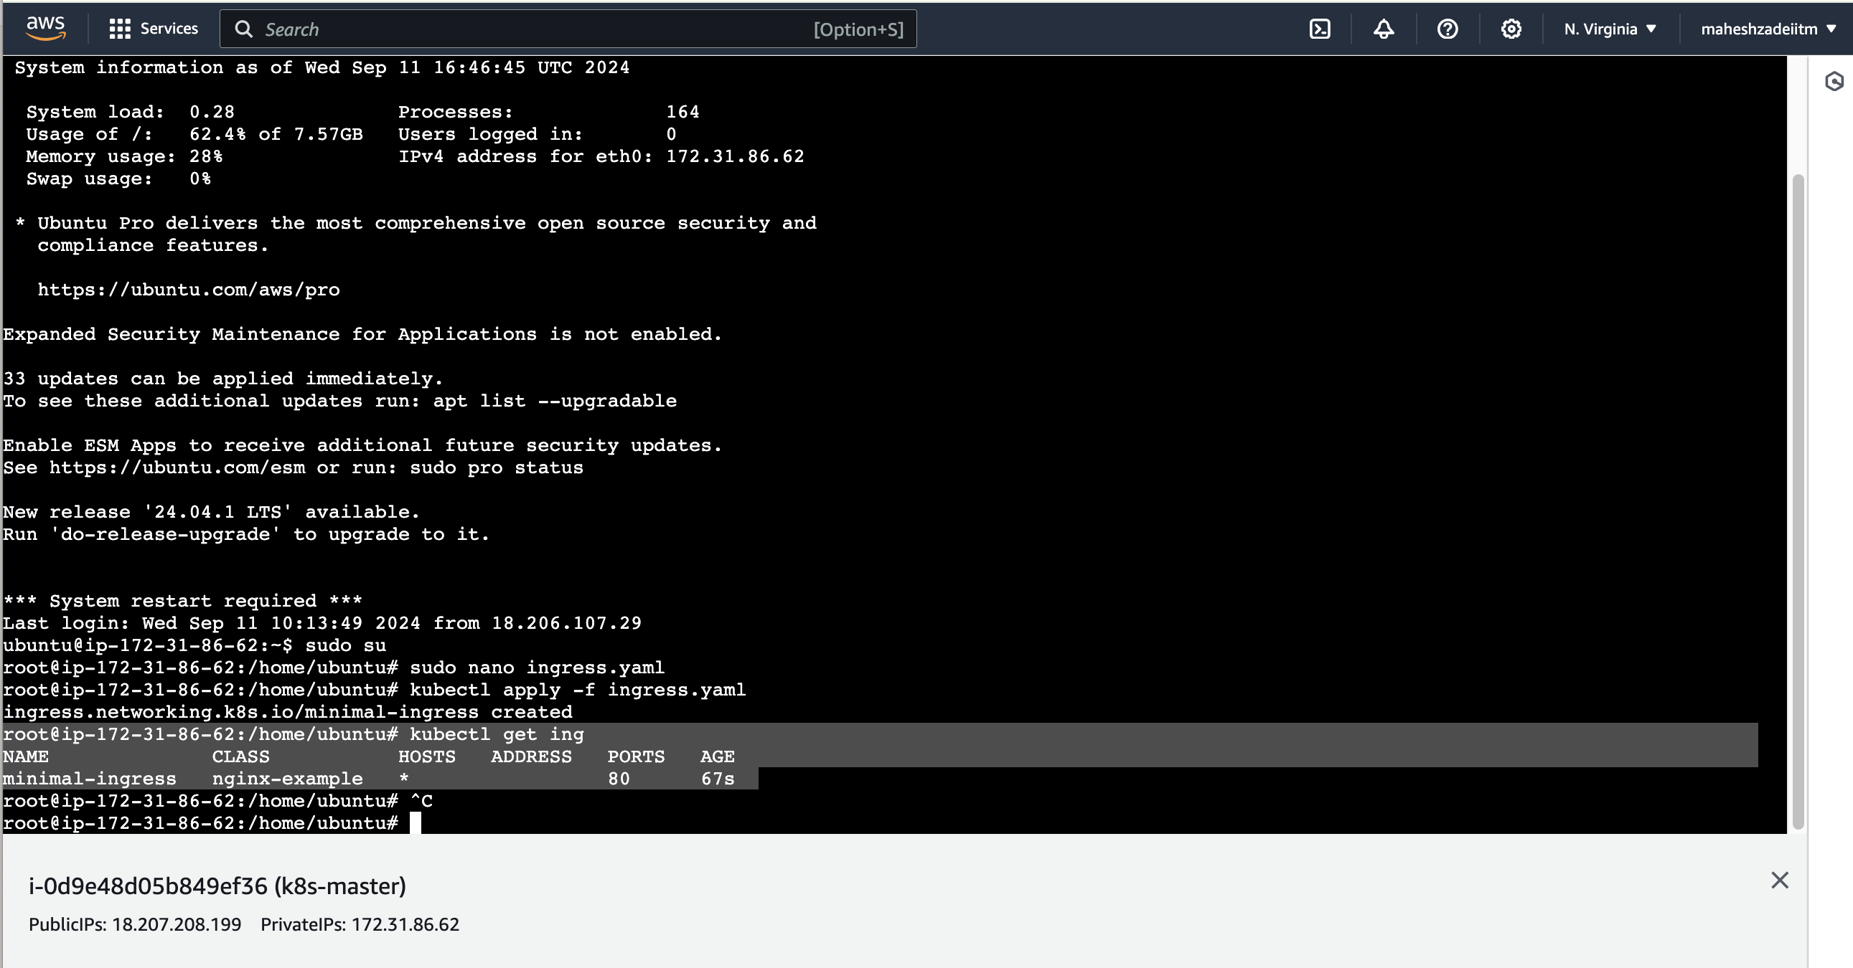

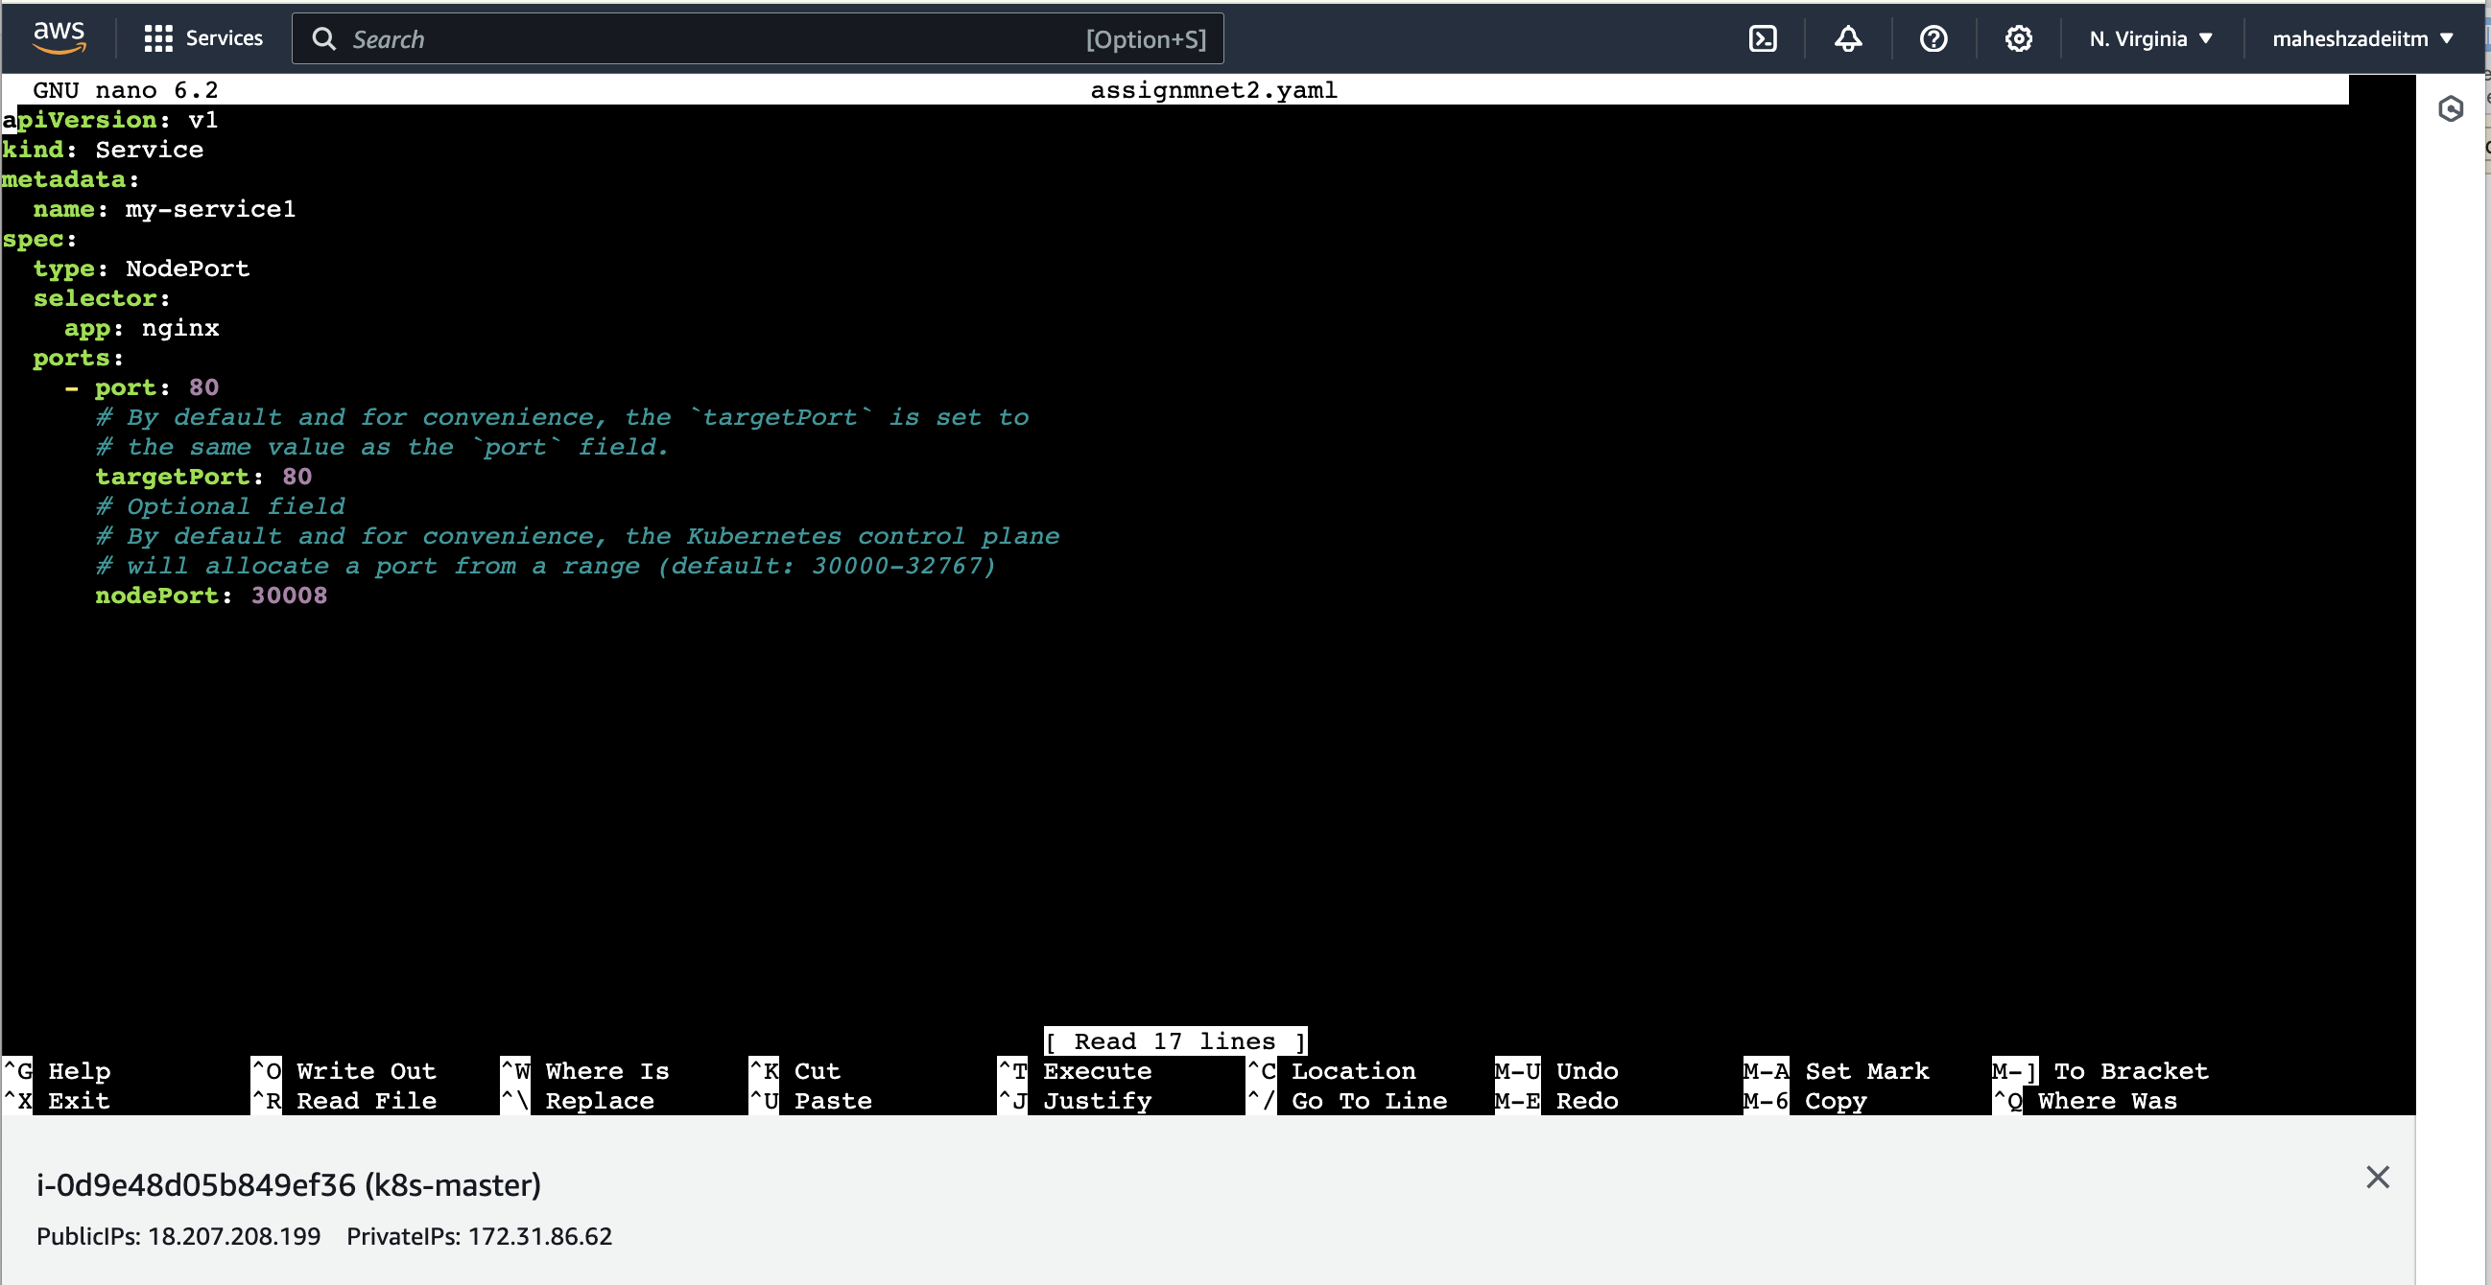

Change name as my-service1

root@ip-172-31-86-62:/home/ubuntu# kubectl apply -f assignmnet2.yaml

service/my-service1 created

also change name as my-service1 in ingress.yaml

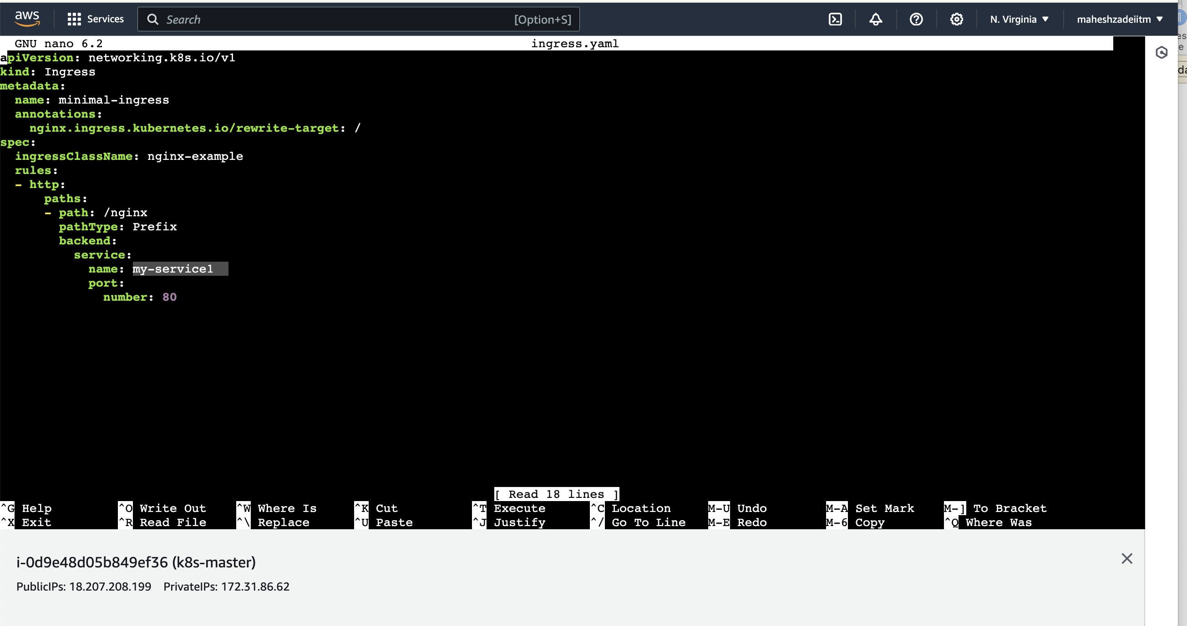

And save it.

Run the below command

root@ip-172-31-86-62:/home/ubuntu# kubectl apply -f ingress.yaml

ingress.networking.k8s.io/minimal-ingress configured.

Run the below command

root@ip-172-31-86-62:/home/ubuntu# kubectl get ing

NAME CLASS HOSTS ADDRESS PORTS AGE

minimal-ingress nginx-example \* 80 17m

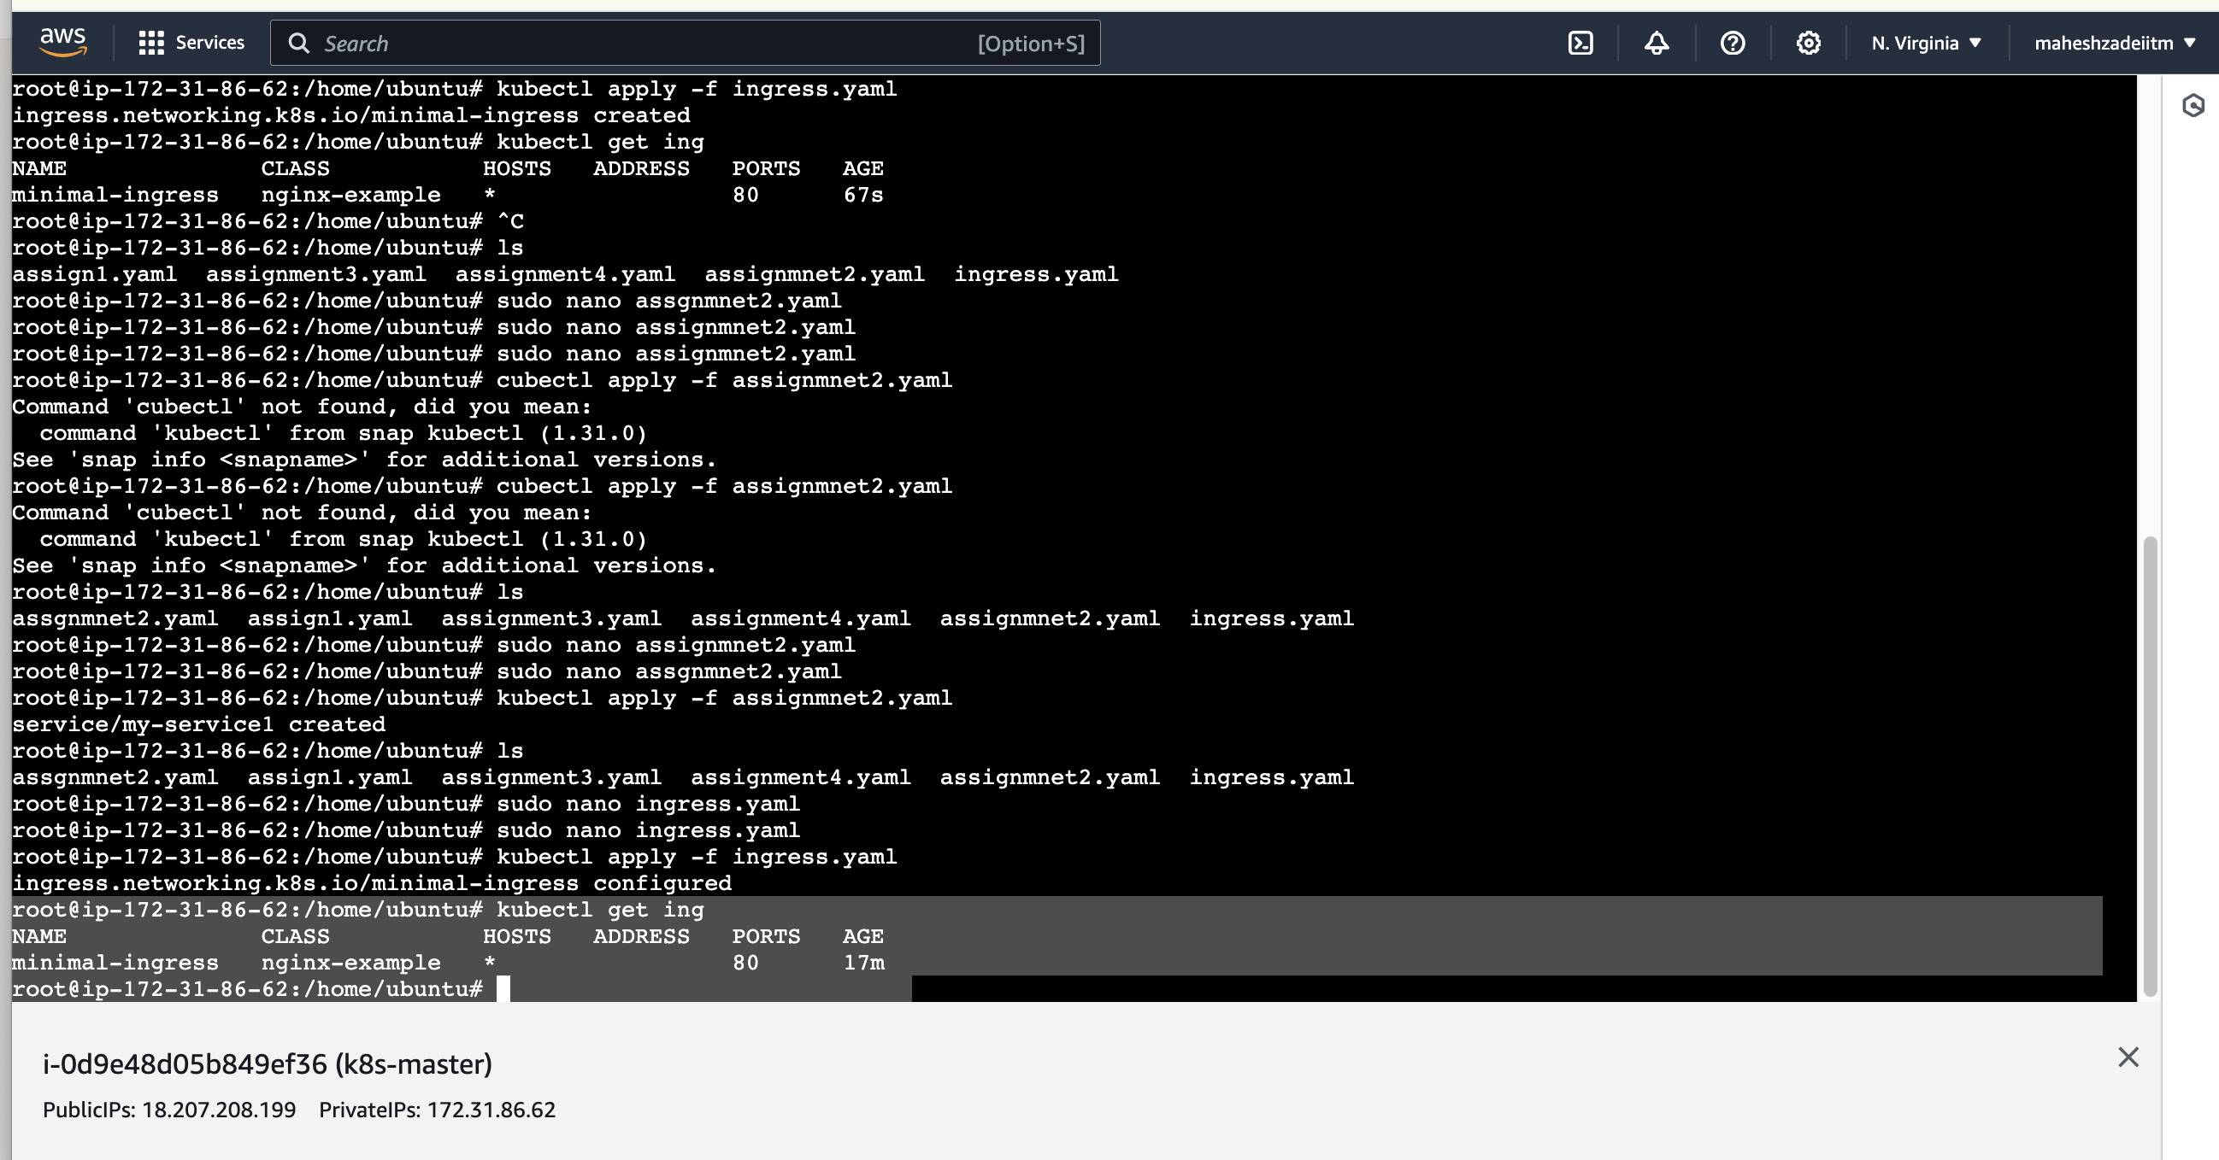

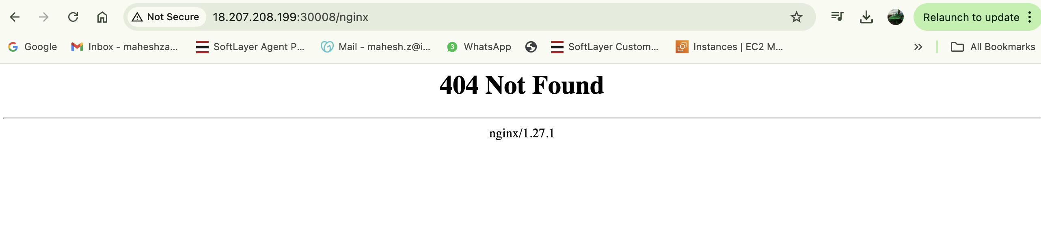

As per the trainer link shared in EKS this issue may not come but in third part tool it give this message .

Thanks